EXPENSE MANAGEMENT SYSTEM
A project report submitted to the University of Madras Chennai
In partial fulfillment of the requirement for the award of the degree of

BACHELOR OF COMPUTER APPLICATIONS



Submitted
By

N. ARUN - 212205581
R. GOKULAKANNAN - 212205588
G. HARIHARAN - 212205589

Guide and supervisor
Mrs. K. THANGAMARI MCA., M.Phil.,

Department of Computer Applications

GOVERNMENT ARTS AND SCIENCE COLLEGE, NEMMELI East Coast Road, Nemmeli-603 104
Chengalpattu District, Tamil Nadu.
2024-2025

BONAFIDE CERTIFICATE

This to certify that the Mini Project Report submitted by N.ARUN (212205581), R.GOKULAKANNAN (212205588), g.HARIHARAN (212205589), final year BCA for the award of the degree of Bachelor of Computer Applications is based on the work carried out by her/him titled “EXPENSE MANAGEMENT SYSTEM”.

Project Guide
Mrs. K. THANGAMARI MCA., M.Phil.,

Head of the department
Mrs. D.K. PRIYA MCA., M.Phil., SET,

PRINCIPAL
DR. V.P.V. SUGANTHI M.A., M.Phil., Ph.D.

Submitted to Viva-Voce Examination held on …………………….

INTERNAL EXAMINER EXTERNAL EXAMINER

DECLARATION

The project entitled “EXPENSE MANAGEMENT SYSTEM” has been caried out by me in the department of Computer Application Government Arts & Science College Nemmeli-603 104 and the contents having been presented in the form of project submitted to UNIVERSITY OF MADRAS CHENNAI-600005 in partial fulfilment of the requirements for the Degree of BACHELOR OF COMPUTER APPLICATIONS.
It is further declared that this project or any part there of has not been submitted on the university or elsewhere for any other degree or diploma to the best of my knowledge.

Place: NEMMELI
Date: Signature of the candidate

ACKNOWLEDGEMENT

We take this opportunity to express our sincere gratitude to all those who helped us in various capacities in undertaking this project and devising the report. We are privileged to express our sense of gratitude to our respected teacher Mrs. K. THANGAMARI MCA., M.Phil., whose unparalleled knowledge, moral fiber and judgement along with his know-how, was an immense support in completing the project.
We are also grateful to Mrs. D.K. PRIYA MCA., M.Phil., SET, the Head of Department, Computer Application, for the brainwave and encouragement given.
We take this opportunity also to thank our friends and contemporaries for their cooperation and compliance.

PREFACE

In a world where financial awareness is key to stability, we proudly present "Expense Management System", your ultimate solution for effortless expense tracking.
With just a few clicks, take control of your finances like never before. Whether you're planning monthly expenses or keeping an eye on daily spending, our system ensures a smooth and organized experience. Join us as we redefine personal finance management—one smart transaction at a time. Welcome to Expense Management System, where every rupee counts!

ABSTRACT

In today's fast-paced world, effective expense management is crucial for individuals and businesses alike. The Expense Management System is a web-based application designed to streamline the process of tracking and managing daily, weekly, and monthly expenses. Developed using PHP and MySQL, this platform offers a user-friendly interface that allows users to set budgets, add expenses, and generate detailed reports and graphs, providing valuable insights into spending patterns. The system ensures compatibility across devices, enhancing accessibility for users on smartphones, tablets, and desktops.
Key features of the Expense Management System include secure user authentication, personalized user dashboards, comprehensive expense tracking, and dynamic expense reporting with graphical representations. By leveraging these features, users can achieve better financial control, make informed financial decisions, and identify potential areas for cost-cutting. The Expense Management System aims to empower users in managing their finances efficiently, ultimately contributing to improved financial well-being and stability.

CONTENTS

Chapter No. | Particulars | Page No.
1 | Introduction and System Overview  1.1 Introduction  1.2 Key Features  1.3 Scope  1.4 System Overview | 01-05
2 | System Objectives and Specifications  2.1 Objectives  2.2 Drawbacks of the Existing System  2.3 Proposed System  2.4 Specifications | 06-09
3 | Requirements and System Design  3.1 Functional Requirement  3.2 Non- functional Requirement  3.3 Architectural Diagram  3.4 Data Flow Diagrams (DFDs)  3.5 Architectural Design | 10-15
4 | System Quality Measures  4.1 Security Consideration  4.2 Scalability and Performance | 16-18
5 | Deployment & Maintenance  5.1 Deployment Strategy  5.2 Monitoring and Maintenance | 19-21
6 | Appendices  6.11 Source code  6.2 Website Screenshots  6.3 Database Tables | 22-54
7 | Conclusion | 55
8 | References | 56

CHAPTER 1
INTRODUCTION AND SYSTEM OVERVIEW

1.1 Introduction
We are developing a PHP-based web application named "Expense Management System", designed to help users efficiently track and manage their daily expenses. This application simplifies the process of recording transactions, analyzing spending habits, and managing budgets, eliminating the need for manual calculations and paperwork.
With this system, users can input their income details, track daily, weekly, and monthly expenses, and generate detailed reports based on transaction dates or expense categories. The data is securely stored for each unique user, ensuring privacy and easy access whenever needed.
This application will be deployed on a web server and application server, with provisions for load balancing to ensure smooth performance even under high usage. As a financial management tool, the Expense Management System serves an essential purpose in organizing personal finances and helping users make informed financial decisions.
The software has undergone the design, development, and testing phases as part of the Software Development Lifecycle (SDLC). The interface is designed to be user-friendly, ensuring that users can effortlessly enter expense details, categorize transactions, and generate reports in various formats such as graphs, PDFs, and printable reports.

1.2 Key Features
✔ Expense Tracking: Users can record daily transactions, including amount, date, Transaction categories.
✔ Budgeting & Planning: Users can set monthly budgets and track their progress to prevent overspending.
✔ Detailed Reports: Expenses can be analyzed daily, weekly, monthly, and yearly in tabular and graphical formats.

✔ Secure Data Storage: No sensitive personal data is stored, ensuring privacy and security.
✔ Future Forecasting: The system allows users to analyze financial trends, plan future budgets, and avoid financial stress.

Managing personal finances is an essential part of everyday life, and budgeting plays a crucial role in maintaining financial stability. Traditionally, many people mentally track their expenses or use manual record-keeping, which often leads to inaccuracies and missed opportunities for better financial planning. Our Expense Management System solves this issue by providing an automated, structured, and user-friendly platform that allows users to keep track of their income and expenses, analyze financial trends, and make informed financial decisions.
By using this system, users can effectively monitor their financial health, avoid unnecessary expenses, and ensure better savings, leading to a more stable and secure financial future.

1.3 Scope
1.3.1 Navigating the Financial Landscape
In today's fast-paced world, managing personal finances efficiently has become essential. The expense management system is designed to simplify expense tracking, budgeting, and financial planning, offering users a structured way to monitor their income and spending. This system provides a digital solution to manual expense tracking, eliminating the risk of errors, missing transactions, and financial mismanagement.
1.3.2 Financial Management Trends
The increasing reliance on digital financial tools has shaped the way people manage their expenses. The scope of expense tracking applications extends beyond basic calculations to comprehensive financial planning, including automated budgeting, spending analytics, and category-wise expense tracking. The demand for such systems is driven by a growing awareness of financial stability, debt management, and savings goals.

1.3.3 Technological Innovations
The expense management system leverages modern technology to enhance user experience and efficiency. Key innovations include:
- User-friendly interface for effortless tracking of expenses
- Automated calculations to ensure accuracy in financial records
- Cloud-based storage for secure and accessible financial data
- Graphical representation of spending trends to assist users in making informed financial decisions
1.3.4 Operational Challenges & Solutions
Despite the advantages, traditional manual expense tracking faces several challenges:
- Data loss and inconsistency in traditional notebooks and spreadsheets
- Time-consuming calculations leading to errors
- Lack of proper financial insights to analyze spending patterns
The expense management system addresses these challenges by providing a digital platform that automates financial tracking, ensuring accurate records and valuable insights into personal spending habits.
1.3.5 Future Prospects
With the growing demand for financial literacy and budgeting tools, the expense management system will continue to evolve by integrating AI-driven expense categorization, real-time financial tips, and predictive budgeting. Future developments may include:
- Multi-user access for family or business expense tracking
- Integration with banking APIs for automated transaction tracking
- Expense forecasting using AI-based financial analysis

1.3.6 Key Features of the Expense Management System
- User registration and login – Secure authentication for personalized financial management
- Expense tracking – Users can record expenses under various categories
- Report generation – Provides detailed financial reports in PDF, graphical, and tabular formats
- Secure data storage – Ensures user financial data remains private and protected
- Customizable financial categories – Allows users to define their own expense categories for better tracking
The expense management system is more than just a tracking tool—it is a comprehensive financial management solution that helps users analyze, plan, and improve their financial health. By leveraging automation, security, and analytics, this system empowers users to take control of their finances efficiently and effectively.

1.4 System Overview:
The expense management system consists of a frontend application for users to input, track, and analyze their expenses, along with a backend system that securely stores and processes financial data. The system is designed to help users set budgets, categorize transactions, and generate reports for better financial planning.
1.4.1 Key Points:
- The expense management system is a user-friendly web application that provides a convenient and efficient way for users to track their financial transactions.
- The system offers a range of features, including a simple interface, categorized expense tracking, and detailed financial reports.
- Based on user feedback, improvements have been made to enhance usability, ensuring an intuitive experience for all users.

1.4.2 Achievements:
- Successfully implemented core features, such as income and expense tracking, budgeting, and financial reporting.
- Optimized system performance to ensure quick data processing and seamless user experience.
- Increased user engagement by integrating graphical insights and intuitive financial summaries.
- Conducted thorough testing and debugging to ensure accuracy and reliability of the system.
- Collaborated effectively to complete the project within the defined scope and deadlines.
- The expense management system provides a valuable tool for users to improve financial awareness and manage their expenses efficiently.

CHAPTER 2
SYSTEM OBJECTIVES AND SPECIFICATIONS

2.1 Objectives
2.1.1 Simplifying Financial Management
The primary objective of the expense management system is to provide users with a simple yet powerful tool to track, manage, and analyze their financial transactions efficiently. By offering an intuitive interface and automated financial tracking, the system empowers users to take control of their spending, set budgets, and achieve better financial stability.
2.1.2 Convenience and Accessibility
At the core of this system lies the goal of making expense tracking effortless and accessible to all users. By allowing individuals to log their daily expenses anytime and anywhere, the system ensures that users can monitor their financial health with ease. Whether managing personal expenses or planning a monthly budget, the system provides a seamless experience without the hassle of manual record-keeping.
2.1.3 Expense Categorization and Budgeting
A key objective of the expense management system is to offer a structured way to categorize expenses, allowing users to track where their money is being spent. By providing categorized insights into spending habits, users can identify areas where they can reduce unnecessary expenses and save more effectively. The system also enables users to set monthly budgets, ensuring they stay within their financial limits.
2.1.4 Accuracy and Data Security
Ensuring accuracy and security in financial tracking is crucial. The system eliminates human errors in calculations, automatically processes financial data, and provides users with detailed reports and insights. Additionally, secure data storage mechanisms are implemented to protect users’ financial information from unauthorized access.

2.1.5 Seamless User Experience
The expense management system is designed to provide a smooth and intuitive user experience, making financial tracking simple even for those with minimal technical knowledge. The system incorporates easy-to-navigate dashboards, visual insights, and automated calculations to help users gain clear financial visibility.
2.1.5 Financial Planning and Future Budgeting
One of the key objectives of this system is to help users plan for the future by analyzing their spending trends and financial history. By generating customized financial reports and graphical representations, users can make informed decisions about their finances and plan accordingly for upcoming months.
2.1.6 User Engagement and Continuous Improvement
The system aims to engage users with valuable financial insights and recommendations, helping them develop healthy financial habits. Through continuous updates and enhancements, the system will evolve to include more features, such as AI-powered financial forecasting, automated savings recommendations, and advanced analytics.
2.1.7 Empowering Users for Better Financial Control
Beyond just tracking expenses, this system aspires to help users build financial discipline and awareness. By maintaining a clear record of income and expenses, users can reduce financial stress, avoid debt traps, and work towards financial independence.
The expense management system is not just a tool, it is a financial companion that simplifies money management, helping users make smarter financial choices and lead a financially secure life.

2.2 Drawbacks of the Existing System
- Expense tracking can be time-consuming if done manually.
- Users may find it difficult to maintain a proper record of their daily expenses.
- Traditional methods, such as using notebooks or spreadsheets, are prone to errors and data loss.
- There is no automated way to analyze spending patterns over time.
- The absence of a structured system may lead to poor financial planning and unnecessary expenses.

2.3 Proposed System
The proposed expense management system is a web-based application developed using PHP (Version 5) and MySQL. It provides users with a simple and effective way to track daily expenses without the need for complex budgeting or categorization. This system allows users to add expenses, view their expense history, and analyze their spending habits over time.
2.3.1 Features of the Proposed System
- Add expense: Users can enter their daily expenses, specifying the amount and description.
- View expenses: Users can check their past expenses in a structured format.
- Manage expenses: Users can update or delete previously added expenses.
- Secure login: Users must log in to access their expense records, ensuring data privacy.
- Database storage: All expense records are securely stored in a MySQL database for easy retrieval.
By implementing this system, users can better manage their financial records, reduce manual tracking efforts, and improve overall financial awareness.

2.3.2 Advantages
- Simple and user-friendly interface for tracking expenses.
- Eliminates the need for paper-based or spreadsheet tracking.
- Secure login system ensures privacy of financial records.
- Fast and efficient retrieval of past expenses for analysis.
- Helps users keep an organized record of their financial transactions.

2.4 Specifications
2.4.1 Hardware Specifications
- Processor: Dual-core processor 2.6 GHz
- RAM: 1 GB
- Hard Disk: 160 GB
- Compact Disk: 650 MB
- Keyboard: Standard keyboard
- Monitor: 15-inch color monitor
2.4.2 Software Specifications
- Front End: PHP, HTML, CSS, JavaScript
- Back End: MySQL
- Development Environment: Visual Studio Code
- Technologies Used: PHP (Version 5), MySQL Database
- Type: Web Application

CHAPTER 3
REQUIREMENTS AND SYSTEM DESIGN

3.1 Functional Requirements
3.1.1 User Registration and Authentication
- Users should be able to register with the website.
- Users should be able to log in securely using their email or username and password.
3.1.2 Expense Entry and Tracking
- Users should be able to add, edit, and delete expenses.
- Expenses should be categorized under predefined or custom categories.
- The system should store the date and time of each expense entry.
3.1.3 Budget Management
- Users should be able to set a monthly budget.
- The system should track expenses against the set budget.
- Notifications should be provided when spending exceeds the budget limit.
3.1.4 Reports and Analytics
- Users should be able to generate reports based on daily, weekly, monthly, and yearly expenses.
- Reports should be available in tabular, graphical, and printable formats.
- The system should allow filtering expenses by date range and category.
3.1.5 User Account Management
- Users should be able to update their profile information, including name, email, and password.
- Users should be able to change their budget preferences.

3.1.6 User Dashboard
- The user should be able to view their expense records for:
    - Today’s spending
    - Yesterday’s spending
    - Last 7 days’ total expenses
    - Last 30 days’ total expenses
    - Remaining balance from the allocated budget
- The system should display these details in the form of cards for easy visualization.
3.1.7 Data Backup and Recovery
- Users should be able to back up their expense data.
- The system should allow restoring backed-up data in case of accidental loss.

3.2 Non-Functional Requirements
3.2.1 Performance
- The system should respond to user interactions within two seconds.
- It should handle multiple users adding expenses simultaneously without slowing down.
3.2.2 Reliability
- The system should be available 24/7 with minimal downtime.
- It should have fault tolerance mechanisms to recover from unexpected failures.
- Data integrity should be maintained, ensuring accurate financial records.
3.2.3 Security
- Secure authentication should be implemented to prevent unauthorized access.
- User data should be encrypted to ensure privacy and protection from breaches.
- The system should use HTTPS for secure data transmission.

3.2.4 Usability
- The interface should be intuitive and easy to navigate.
- The system should be optimized for both desktop and mobile devices.
- Accessibility features should be included for users with disabilities.
3.2.5 Scalability
- The database should be designed to accommodate an increasing number of users and transactions.
- The system should be deployable on scalable cloud infrastructure to handle growing demand.
The Expense Management System is designed to provide users with an efficient, secure, and scalable platform to track and manage their finances with ease.

3.3 Architectural Diagram
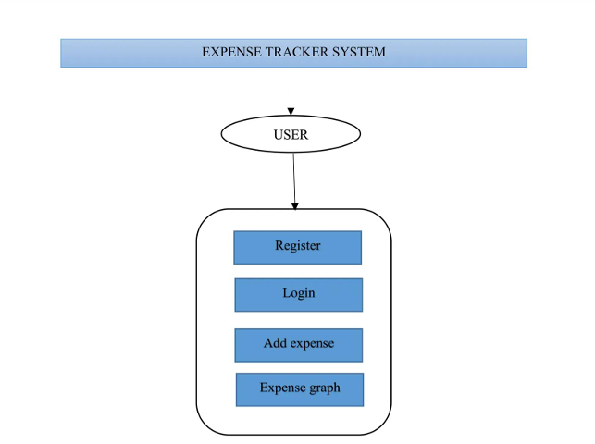

Architectural Diagram of Expense management System

An architecture diagram visually represents how these components interact. It typically includes:
- Users interacting with the system through a web browser.
- Requests being processed by the PHP backend.
- Data being stored and retrieved from the MySQL database.
This architecture ensures scalability, maintainability, and security, providing a stable environment for users to track and manage their expenses efficiently.

3.4 Data Flow Diagrams (DFDs)
A data flow diagram (DFD) is a two-dimensional graphical representation that explains how data moves through a system. It helps visualize how data is processed, transferred, and stored, making it useful for both business and development teams. DFDs identify external data sources, inputs, outputs, and their interactions within the system, aiding in process optimization and system design improvements.
3.4.1 Level 0 DFD (Context Diagram)
Level 0 DFD, also known as a Context Diagram, provides a high-level overview of the entire expense management system. It represents the system as a single process interacting with external entities such as users and the database. This diagram is designed to be easily understood by business analysts, stakeholders, and developers.
At this level, the expense management system receives expense details from the user, processes them, and stores them in the database. The system also allows users to retrieve and view their recorded expenses.
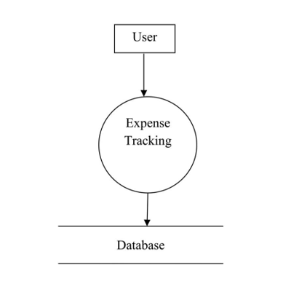
Level 0 DFD

3.4.2 Level 1 DFD
Level 1 DFD provides a detailed breakdown of the Context Diagram by splitting the main process into sub-processes that define the system’s functionalities. It represents how data flows through different components, including:
- User Authentication: Validates user credentials and grants access.
- Expense Entry: Allows users to input and store expense records.
- Expense Management: Enables users to update or delete existing expense entries.
- Report Generation: Fetches stored data and displays reports for analysis.
Level 1 DFD provides clarity on how different components interact within the system while maintaining the balance of inputs and outputs from the context diagram.
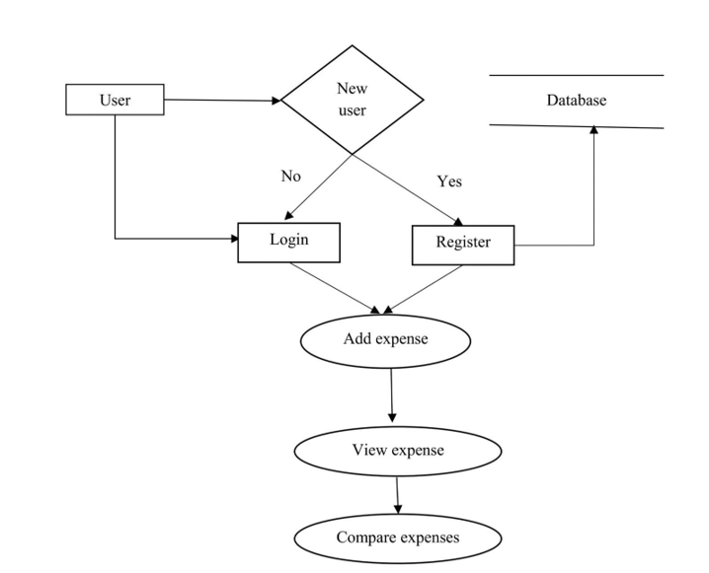
Level 1 DFD

3.5 Architectural Design
System architecture defines the structure, components, and behaviour of the expense management system. It provides a blueprint for development, ensuring that different modules work together efficiently to achieve the system’s goals.
3.5.1 System Architecture Components
- User Interface (Frontend): The web-based interface that allows users to interact with the system. Built using HTML, CSS, and JavaScript.
- Backend Logic (Processing Layer): Handles business logic and request processing, developed using PHP.
- Database Management (Storage Layer): Stores user credentials and expense records in MySQL.
- Server and Hosting: The system is hosted on a local server (XAMPP) or web server, ensuring accessibility for users.

CHAPTER 4
SYSTEM QUALITY MEASURES

4.1 Security Consideration
Ensuring data security is a crucial aspect of the expense management system. As this platform deals with users' financial records, implementing robust security measures is necessary to protect sensitive information from unauthorized access, data breaches, and cyber threats.
4.1.1 Data Encryption
- All sensitive data, including user credentials and expense records, should be encrypted during transmission and storage.
- Secure Socket Layer (SSL) or Transport Layer Security (TLS) protocols should be used to ensure encrypted communication between users and the server, preventing unauthorized interception of data.
4.1.2 Secure Authentication
- The system should implement strong authentication mechanisms, requiring users to log in with a unique username and password.
- Multi-factor authentication (MFA) can be integrated as an added layer of security to prevent unauthorized access.
4.1.3 User Privacy Protection
- The platform should comply with data protection standards, ensuring that user financial data is not shared with third parties without consent.
- User access controls should be implemented, allowing only authorized users to access their own financial records.

4.1.4 Vulnerability Management
- Regular security assessments and penetration testing should be conducted to identify and fix vulnerabilities in the system.
- The system should be regularly updated with security patches to prevent exploitation of known vulnerabilities.
4.1.5 Incident Response and Recovery
- A well-defined incident response plan should be in place to detect, contain, and mitigate security breaches.
- Regular backups of expense records should be maintained to ensure data recovery in case of accidental loss or cyberattacks.

4.2 Scalability and Performance
As user demand increases, the expense management system must ensure seamless performance and scalability to handle growing data and traffic efficiently.
4.2.1 Infrastructure Scalability
- The system should be designed to scale efficiently as the number of users and transactions grows.
- A cloud-based hosting solution can be used to dynamically allocate resources based on demand.
4.2.2 Database Scalability
- MySQL should be optimized to handle large volumes of expense records while ensuring quick data retrieval.
- Indexing and query optimization techniques should be implemented to improve database performance.

4.2.3 Load Balancing
- The system should distribute workload efficiently across multiple servers to prevent overload and ensure smooth performance.
- Caching mechanisms should be used to store frequently accessed data, reducing the load on the database and improving response times.
By integrating these security and scalability measures, the expense management system will provide a reliable, secure, and efficient platform for users to track and manage their financial records without performance issues or security risks.

CHAPTER 5
DEPLOYMENT AND MAINTENANCE

5.1 Deployment Strategy
Deploying the expense management system requires careful planning to ensure a smooth transition, minimize downtime, and provide a seamless user experience. From preparation to post-deployment monitoring, the following strategy outlines key steps for successful deployment.
5.1.1 Pre-Deployment Planning
- Define deployment objectives, including performance expectations and user accessibility.
- Assess server and database requirements to ensure compatibility with the application.
- Conduct risk assessments to identify potential deployment challenges.
5.1.2 Environment Management
- The system will be tested in different environments, including development, testing, staging, and production, to ensure stability.
- Version control tools like Git will be used to manage code versions and track changes.
- XAMPP will be used for local testing before deploying to a live web server.
5.1.3 Continuous Integration and Deployment
- Implement a structured deployment pipeline to automate code updates.
- Regular updates will be tested to ensure stability before being released to the production server.
- Scheduled backups will be created before each deployment to avoid data loss.

5.1.4 Rollout Strategy
- The system will be deployed in phases to minimize risks and ensure smooth user adoption.
- Initial deployment will be tested with a small group of users before full-scale release.
- A rollback plan will be in place to revert to previous versions in case of issues.
5.1.5 Performance and Load Testing
- The system will undergo stress testing to ensure it can handle multiple users simultaneously.
- Database queries will be optimized to improve response time and reduce server load.
- Page load speed and overall application performance will be monitored before final deployment.

5.2 Monitoring and Maintenance
Ensuring long-term performance and security of the expense management system requires continuous monitoring and proactive maintenance.
5.2.1 Performance Monitoring
- Regular tracking of system performance metrics, including response times and server load.
- Tools will be used to identify slow queries and optimize database performance.
5.2.2 Server and Infrastructure Monitoring
- Server uptime, CPU usage, and memory utilization will be monitored to detect potential failures.
- Logs will be analyzed to identify security threats and unexpected crashes.

5.2.3 Security Monitoring
- Regular security scans will be conducted to detect vulnerabilities.
- Secure authentication methods will be monitored to prevent unauthorized access.
- SSL/TLS encryption will be enforced to ensure safe data transmission.
5.2.4 Incident Response and Remediation
- A structured incident response plan will be in place to address system failures or security breaches.
- Quick resolution procedures will be implemented to minimize downtime.
- Root cause analysis will be conducted after any incident to prevent recurrence.
5.2.5 Proactive Maintenance and Optimization
- Regular system updates will be applied to fix bugs and improve performance.
- Database clean-up and optimization will be performed periodically to maintain efficiency.
- User feedback will be collected to enhance the system with necessary improvements.
By following this deployment and maintenance strategy, the expense management system will ensure reliability, security, and scalability, providing users with a seamless financial tracking experience.

CHAPTER 6
APPENDICES
6.1 SOURCE CODE

Index

<?php
include_once "init.php";

// User login check
if (isset($_SESSION['UserId'])) {
header('Location: templates/3-Dashboard.php');
}

// Validate credentials and log the user in
if (isset($_POST['login']) && !empty($_POST)) {
$password = $_POST['password'];
$username = $_POST['username'];

if(!empty($username) || !empty($password)) {
$username = $getFromU->checkInput($username);
$password = $getFromU->checkInput($password);
if($getFromU->login($username, $password) === false) {
$error = "The username or password is incorrect";
}
}
}
?>

<!DOCTYPE html>
<html lang="en">

<head>
<meta charset="UTF-8">
<meta name="viewport" content="width=device-width, initial-scale=1.0">
<link rel="icon" href="static/images/wallet.png" sizes="16x16" type="image/png">
<link rel="stylesheet" href="static/css/index.css">
<link href="https://fonts.googleapis.com/css2?family=Source+Sans+Pro:wght@600&display=swap" rel="stylesheet">
<link href="https://fonts.googleapis.com/css2?family=Raleway:wght@300&display=swap" rel="stylesheet">
<link rel="stylesheet" href="https://cdnjs.cloudflare.com/ajax/libs/font-awesome/5.9.0/css/all.css">
<link rel="stylesheet" href="https://stackpath.bootstrapcdn.com/font-awesome/4.7.0/css/font-awesome.min.css"
integrity="sha384-wvfXpqpZZVQGK6TAh5PVlGOfQNHSoD2xbE+QkPxCAFlNEevoEH3Sl0sibVcOQVnN" crossorigin="anonymous">

<title>Expense Management</title>
</head>

<body>
<div class="container">

<div class="mob-hidden">
<h1>EMS</h1>
</div>

<div class="top-heading">
<h1>Expense Management System</h1>
</div>
<form action="index.php" method="post" onsubmit = "return validate()" id="form1">

<div class="group">

<div class="form-controller">
<i class="fa fa-user-plus u3" aria-hidden="true"></i>
<input type="text" name="username" placeholder="Username" id="user1" required>
<br>
<small></small>
</div>

<div class="form-controller">
<i class="fa fa-key u4" aria-hidden="true"></i>
<input type="password" name="password" placeholder="Password" id="pass1" autocomplete="on" required>
<br>
<small></small>
</div>

</div>
<button type="submit" class="sign-in" name="login">Log In</button>

<br>
<?php
if (isset($error)) {
$font = "Source Sans Pro";
echo '<div style="color: red;font-family:'.$font.';">'.$error.'</div>';
}
?>

<div class="new-account">
<span style="color: rgba(0, 0, 0, 0.54); font-weight: bolder; font-family: 'Source Sans Pro';">Don't have an account?</span>
<a href="templates/2-sign-up.php" style="text-decoration: none;"><span style="color: rgba(5, 0, 255, 0.81); font-weight: bolder; font-family: 'Source Sans Pro';">Sign Up Now</span></a>
</div>

</form>

<div class="img-container">
<img src="static/images/login.png" alt="Login-screen-picture">
</div>
</div>

<script src="static/js/index.js"></script>
</body>

</html>

USER

<?php
class User extends Base{
function __construct($pdo)
{
$this->pdo = $pdo;
}

// Removes extra space and html code from input
public function checkInput($var)
{
$var = htmlspecialchars($var);
$var = trim($var);
$var = stripslashes($var);
return $var;
}

// Logs a user in
public function login($username, $password)
{
$stmt = $this->pdo->prepare("SELECT UserId FROM user WHERE Username = :username AND Password = :password");
$stmt->bindParam(":username", $username, PDO::PARAM_STR);
$hash = md5($password);
$stmt->bindParam(":password", $hash, PDO::PARAM_STR);
$stmt->execute();
$user = $stmt->fetch(PDO::FETCH_OBJ);
$count = $stmt->rowCount();

if($count>0)
{

$_SESSION['UserId'] = $user->UserId;
header("Location: templates/3-Dashboard.php");
}
else
{
return false;
}
}

// Checks if email already exists
public function checkEmail($email)
{
$stmt = $this->pdo->prepare("SELECT UserId FROM user WHERE Email = :email");
$stmt->bindParam(":email", $email, PDO::PARAM_STR);
$stmt->execute();
$user = $stmt->fetch(PDO::FETCH_OBJ);
$count = $stmt->rowCount();
if($count>0)
{
return true;
}
else
{
return false;
}
}

// Checks if username already exists
public function checkUsername($username)
{
$stmt = $this->pdo->prepare("SELECT UserId FROM user WHERE Username = :username");
$stmt->bindParam(":username", $username, PDO::PARAM_STR);
$stmt->execute();
$user = $stmt->fetch(PDO::FETCH_OBJ);
$count = $stmt->rowCount();
if($count>0)
{
return true;
}
else
{
return false;
}
}

// Returns the path of profile picture from database by user id
public function Photofetch($UserId) {
$stmt = $this->pdo->prepare("SELECT Photo FROM user WHERE UserId = :UserId");
$stmt->bindParam(":UserId", $UserId, PDO::PARAM_INT);
$stmt->execute();
$user = $stmt->fetch(PDO::FETCH_OBJ);
return $user->Photo;
}

// Logs a user out
public function logout()
{
session_destroy();
header("Location: ". BASE_URL .'index.php');
}

// Checks if a user is logged in
public function loggedIn()
{
if (isset($_SESSION['UserId'])) {
return true;
}
return false;
}

// Returns a user's entire data
public function userData($user_id) {
$stmt = $this->pdo->prepare("SELECT * FROM user WHERE UserId = :user_id");
$stmt->bindParam(":user_id", $user_id, PDO::PARAM_INT);
$stmt->execute();
return $stmt->fetch(PDO::FETCH_OBJ);
}

}
?>

EXPENSE

<!DOCTYPE html>
<html lang="en">
<?php
include("connection/connect.php");
error_reporting(0);
session_start();
?>
<head>
<meta charset="utf-8">
<meta http-equiv="X-UA-Compatible" content="IE=edge">
<meta name="viewport" content="width=device-width, initial-scale=1, shrink-to-fit=no">
<meta name="description" content="">
<meta name="author" content="">
<link rel="icon" href="#">
<title>Restaurants</title>
<link href="css/bootstrap.min.css" rel="stylesheet">
<link href="css/font-awesome.min.css" rel="stylesheet">
<link href="css/animsition.min.css" rel="stylesheet">
<link href="css/animate.css" rel="stylesheet">
<link href="css/style.css" rel="stylesheet"> </head>

<body>
<header id="header" class="header-scroll top-header headrom">

BUDGET

<?php
class Budget extends Base {
function __construct($pdo) {
$this->pdo = $pdo;
}
// To check validity of the set budget
public function budget_validity_checker($UserId){
$stmt = $this->pdo->prepare("SELECT EXTRACT(MONTH FROM RDATE) AS mon FROM budget WHERE UserId = :user");
$stmt->bindParam(":user", $UserId, PDO::PARAM_INT);
$stmt->execute();
$r = $stmt->fetch(PDO::FETCH_OBJ);
if($r == NULL)
{
return true;
}
else
{
$val1 = $r->mon;
}
$stmt2 = $this->pdo->prepare("SELECT EXTRACT(MONTH FROM CURRENT_TIMESTAMP()) AS current");
$stmt2->execute();
$z = $stmt2->fetch(PDO::FETCH_OBJ);
$val2 = $z->current;
if($val1 === $val2)
{
return true;
}
else
{
return false;
}
}
// To set the budget
public function setbudget($UserId, $budget) {
$stmt = $this->pdo->prepare("INSERT INTO budget(UserId, Budget) VALUES(:user , :amount)");
$stmt->bindParam(":user", $UserId, PDO::PARAM_INT);
$stmt->bindParam(":amount", $budget, PDO::PARAM_INT);
$stmt->execute();
}
// To check the current budget
public function checkbudget($UserId) {
$stmt = $this->pdo->prepare("SELECT Budget AS currentbudget FROM budget WHERE UserId=:user");
$stmt->bindParam(":user", $UserId, PDO::PARAM_INT);
$stmt->execute();
$rows = $stmt->fetch(PDO::FETCH_OBJ);
if($rows == NULL)
{
return NULL;
}
else
{
return $rows->currentbudget;
}
}
// To update current budget
public function updatebudget($UserId, $budget) {
$stmt = $this->pdo->prepare("UPDATE budget SET Budget = :amount, RDATE = CURRENT_TIMESTAMP() WHERE UserId = :user");
$stmt->bindParam(":user", $UserId, PDO::PARAM_INT);
$stmt->bindParam(":amount", $budget, PDO::PARAM_INT);
$stmt->execute();
}
// To delete the monthly budget record (Once the month changes)
public function del_budget_record($UserId){
$stmt = $this->pdo->prepare("DELETE FROM budget WHERE UserId = :user");
$stmt->bindParam(":user", $UserId, PDO::PARAM_INT);
$stmt->execute();
}
}
?>

DASHBOARD

<?php
include_once "../init.php";
//User login check
if ($getFromU->loggedIn() === false) {
header('Location: ../index.php');
}
include_once 'skeleton.php';
if (isset($_SESSION['swal']))
{
echo $_SESSION['swal'];
unset($_SESSION['swal']);
}
// Budget validity checker
$budget_validity = $getFromB->budget_validity_checker($_SESSION['UserId']);
if($budget_validity == false)
{
$getFromB->del_budget_record($_SESSION['UserId']);
}
// Today's Expenses
$today_expense = $getFromE->Expenses($_SESSION['UserId'],0);
if($today_expense == NULL)
{
$today_expense = "No Expenses Logged Today";
}
else
{
$today_expense = "₹ ".$today_expense;
}
// Yesterday's Expenses
$Yesterday_expense = $getFromE->Yesterday_expenses($_SESSION['UserId']);
if($Yesterday_expense == NULL)
{
$Yesterday_expense = "No Expenses Logged Yesterday";
}
else
{
$Yesterday_expense = "₹ ".$Yesterday_expense;
}
// Last 7 Days' Expenses
$week_expense = $getFromE->Expenses($_SESSION['UserId'],6);
if($week_expense == NULL)
{
$week_expense = "No Expenses Logged This Week";
}
else
{
$week_expense = "₹ ".$week_expense;
}

// Last 30 Days' Expenses
$monthly_expense = $getFromE->Expenses($_SESSION['UserId'],29);
if($monthly_expense == NULL)
{
$monthly_expense = "No Expenses This Month";
}
else
{
$monthly_expense = "₹ ".$monthly_expense;
}
// Total Expenses
$total_expenses = $getFromE->totalexp($_SESSION['UserId']);
if($total_expenses == NULL)
{
$total_expenses = "No Expenses Logged Yet";
}
else
{
$total_expenses = "₹ ".$total_expenses;
}
// Budget Left for the month
$budget_left = $getFromB->checkbudget($_SESSION['UserId']);
if($budget_left == NULL)
{
$budget_left = "Not Set Yet";
}
else
{
$currmonexp = $getFromE->Current_month_expenses($_SESSION['UserId']);
if($currmonexp==NULL)
{
$currmonexp = 0;
}
$budget_left = $budget_left - $currmonexp;
$budget_left = "₹ ".$budget_left;
}

?>
<div class="wrapper">
<div class="row">
<div class="col-4 col-m-4 col-sm-4">
<div class="card">
<div class="counter bg-danger" style="color:white;">
<p><i class="fas fa-tasks"></i></p>
<h3>
Today's Expenses
</h3>
<p style="font-size: 1.2em;">
<?php echo $today_expense ?>
</p>
</div>
</div>
</div>
<div class="col-4 col-m-4 col-sm-4">
<div class="card">
<div class="counter bg-primary" style="color:white;">
<p><i class="fas fa-undo-alt"></i></p>
<h3>
Yesterday's Expenses
</h3>
<p style="font-size: 1.2em;">
<?php echo $Yesterday_expense ?>
</p>
</div>
</div>
</div>
<div class="col-4 col-m-4 col-sm-4">
<div class="card">
<div class="counter bg-warning" style="color:white;">
<p><i class="fas fa-calendar-week"></i></p>
<h3>
Last 7 day's Expenses
</h3>
<p style="font-size: 1.2em;">
<?php echo $week_expense ?>
</p>
</div>
</div>
</div>
<div class="col-4 col-m-4 col-sm-4">
<div class="card">
<div class="counter bg-vio" style="color:white;">
<p><i class="fas fa-calendar"></i></p>
<h3>
Last 30 day's Expenses
</h3>
<p style="font-size: 1.2em;">
<?php echo $monthly_expense ?>
</p>
</div>
</div>
</div>
<div class="col-4 col-m-4 col-sm-4">
<div class="card">
<div class="counter bg-success" style="color:white;">
<p><i class="fas fa-rupee-sign"></i></p>
<h3>
Monthly Budget Left
</h3>
<p style="font-size: 1.2em;">
<?php echo $budget_left ?>
</p>
</div>
</div>
</div>
<div class="col-4 col-m-4 col-sm-4">
<div class="card">
<div class="counter bg-yell" style="color:white;">
<p><i class="fas fa-file-invoice" aria-hidden="true"></i></p>
<h3>
Total Expenses
</h3>
<p style="font-size: 1.2em;">
<?php echo $total_expenses ?>
</p>
</div>
</div>
</div>
</div>
</div>

PROFILE

<?php
include_once "../init.php";

// User login check
if ($getFromU->loggedIn() === false) {
header('Location: ../index.php');
}
include_once 'skeleton.php';

// Gathering all user data
$userobj = $getFromU->userData($_SESSION['UserId']);
$fullname = $userobj->Full_Name;
$usr_name = $userobj->Username;
$emailid = $userobj->Email;
$JoinDate = $userobj->RegDate;
$picture = $userobj->Photo;
?>

<div class="wrapper">
<div class="row">
<div class="col-12 col-m-12 col-sm-12" >
<div class="card">
<div class="counter" style="display: flex; align-items: center; justify-content: center;">
<form action="">
<h1 style="font-family: 'Source Sans Pro'">Profile</h1>
<div>
<img style="width:100px; height:100px; object-fit: cover; border-radius: 50%;" src=<?php echo '"'.$picture.'"' ?> alt="">
</div>
<div>
<p>Full Name:</p>
<input type="text" class="text-input" style="width: 100%;" value=<?php echo '"'.$fullname.'"' ?> readonly><br>
</div>
<div>
<p>User Name:</p>
<input type="text" class="text-input" style="width: 100%;" value=<?php echo '"'.$usr_name.'"' ?> readonly><br>
</div>
<div>
<p>Email Id:</p>
<input type="email " style="width: 100%;" class="text-input" value=<?php echo '"'.$emailid.'"' ?> readonly><br>
</div>
<div>
<p>Registration Date:</p>
<input type="datetime" class="text-input" style="width: 100%; font-size: 1.1em; padding-left: 45px;" value=<?php echo '"'.$JoinDate.'"' ?> readonly><br>
</div>
<br>
<div><br>
<a href="11-changepass.php"><button type="button" class="pressbutton" name="submit">Change Password</button></a>
</div>
</form>
</div>
</div>
</div>
</div>
</div>
<script src="../static/js/10-Profile.js"></script>

SQL (DATABASE)

-- phpMyAdmin SQL Dump
-- version 4.2.11
-- http://www.phpmyadmin.net
--
-- Host: 127.0.0.1
-- Generation Time: Aug 05, 2023 at 06:44 AM
-- Server version: 5.6.21
-- PHP Version: 5.6.3

SET SQL_MODE = "NO_AUTO_VALUE_ON_ZERO";
SET time_zone = "+00:00";

/*!40101 SET @OLD_CHARACTER_SET_CLIENT=@@CHARACTER_SET_CLIENT */;
/*!40101 SET @OLD_CHARACTER_SET_RESULTS=@@CHARACTER_SET_RESULTS */;
/*!40101 SET @OLD_COLLATION_CONNECTION=@@COLLATION_CONNECTION */;
/*!40101 SET NAMES utf8 */;
--
-- Database: `expenseman`
--
-- --------------------------------------------------------

--
-- Table structure for table `budget`
--
CREATE TABLE IF NOT EXISTS `budget` (
`ID` int(11) NOT NULL,
`UserId` int(11) NOT NULL,
`Budget` decimal(25,2) NOT NULL,
`RDATE` timestamp NOT NULL DEFAULT CURRENT_TIMESTAMP
) ENGINE=InnoDB AUTO_INCREMENT=4 DEFAULT CHARSET=utf8mb4;
--
-- Dumping data for table `budget`
--
INSERT INTO `budget` (`ID`, `UserId`, `Budget`, `RDATE`) VALUES
(3, 2, '7895.00', '2023-06-12 04:50:46');
-- --------------------------------------------------------
--
-- Table structure for table `expense`
--
CREATE TABLE IF NOT EXISTS `expense` (
`UserId` int(11) NOT NULL,
`ID` int(11) NOT NULL,
`Item` varchar(255) NOT NULL,
`Cost` decimal(25,2) NOT NULL,
`Date` timestamp NOT NULL DEFAULT CURRENT_TIMESTAMP
) ENGINE=InnoDB AUTO_INCREMENT=6 DEFAULT CHARSET=utf8mb4;

--
-- Dumping data for table `expense`
--
INSERT INTO `expense` (`UserId`, `ID`, `Item`, `Cost`, `Date`) VALUES
(2, 2, 'Grocery', '196.00', '2023-04-01 13:56:00'),
(2, 4, 'Test Yesterday', '699.00', '2023-06-11 17:55:00'),
(2, 5, 'T220', '2000.00', '2023-06-12 04:52:00');
-- --------------------------------------------------------
--
-- Table structure for table `user`
--
CREATE TABLE IF NOT EXISTS `user` (
`Full_Name` varchar(40) NOT NULL,
`Email` varchar(255) NOT NULL,
`Username` varchar(255) NOT NULL,
`UserId` int(11) NOT NULL,
`Password` varchar(32) NOT NULL,
`Photo` varchar(255) NOT NULL,
`RegDate` timestamp NOT NULL DEFAULT CURRENT_TIMESTAMP
) ENGINE=InnoDB AUTO_INCREMENT=3 DEFAULT CHARSET=utf8mb4;
--
-- Dumping data for table `user`
--
INSERT INTO `user` (`Full_Name`, `Email`, `Username`, `UserId`, `Password`, `Photo`, `RegDate`) VALUES
('Christine Moore', 'christine@mail.com', 'christine', 1, '5f4dcc3b5aa765d61d8327deb882cf99', '../static/images/userlogo.png', '2023-03-26 12:59:25'),
('Claire', 'claire@mail.com', 'claire', 2, '5f4dcc3b5aa765d61d8327deb882cf99', '../static/images/userlogo.png', '2023-03-26 09:16:13');
--
-- Indexes for dumped tables
--
--
-- Indexes for table `budget`
--
ALTER TABLE `budget`
ADD PRIMARY KEY (`ID`);
--
-- Indexes for table `expense`
--
ALTER TABLE `expense`
ADD PRIMARY KEY (`ID`);
--
-- Indexes for table `user`
--
ALTER TABLE `user`
ADD PRIMARY KEY (`UserId`);
--
-- AUTO_INCREMENT for dumped tables
--
--
-- AUTO_INCREMENT for table `budget`
--
ALTER TABLE `budget`
MODIFY `ID` int(11) NOT NULL AUTO_INCREMENT,AUTO_INCREMENT=4;
--
-- AUTO_INCREMENT for table `expense`
--
ALTER TABLE `expense`
MODIFY `ID` int(11) NOT NULL AUTO_INCREMENT,AUTO_INCREMENT=6;
--
-- AUTO_INCREMENT for table `user`
--
ALTER TABLE `user`
MODIFY `UserId` int(11) NOT NULL AUTO_INCREMENT,AUTO_INCREMENT=3;
/*!40101 SET CHARACTER_SET_CLIENT=@OLD_CHARACTER_SET_CLIENT */;
/*!40101 SET CHARACTER_SET_RESULTS=@OLD_CHARACTER_SET_RESULTS */;
/*!40101 SET COLLATION_CONNECTION=@OLD_COLLATION_CONNECTION */;

6.2 WEBSITE SCREENSHOTS

LOGIN PAGE

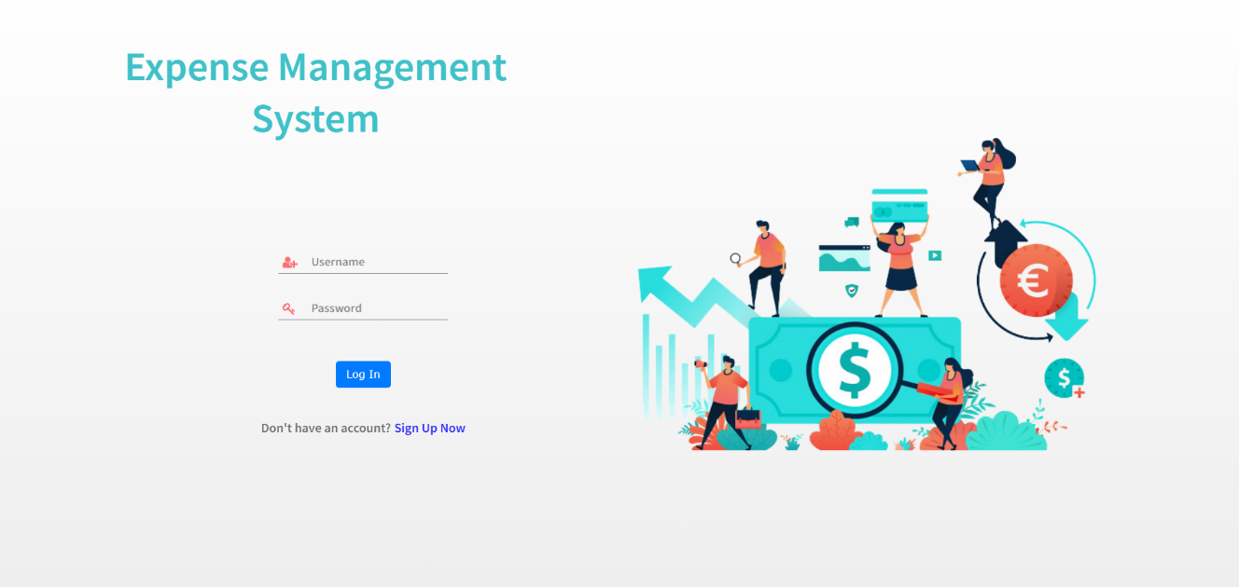

SIGN-UP PAGE

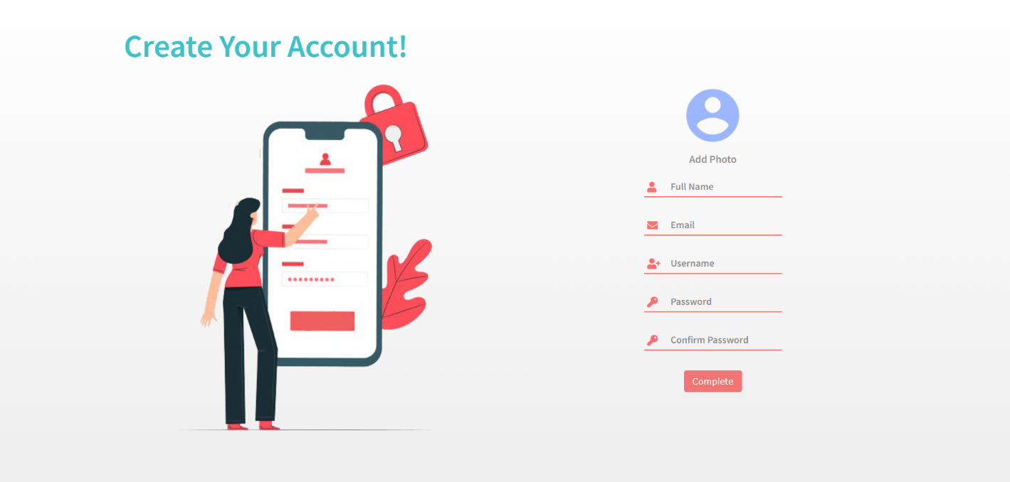

DASHBOARD

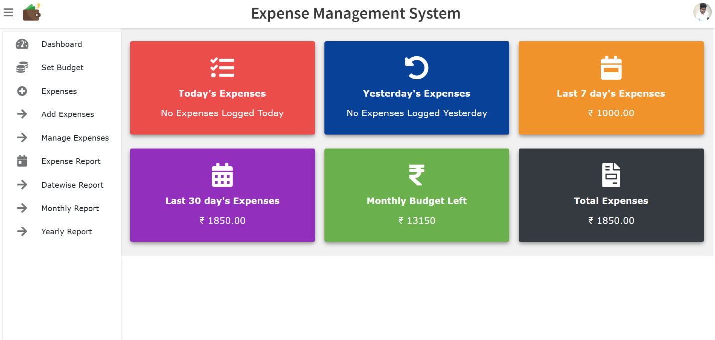

PROFILE PAGE

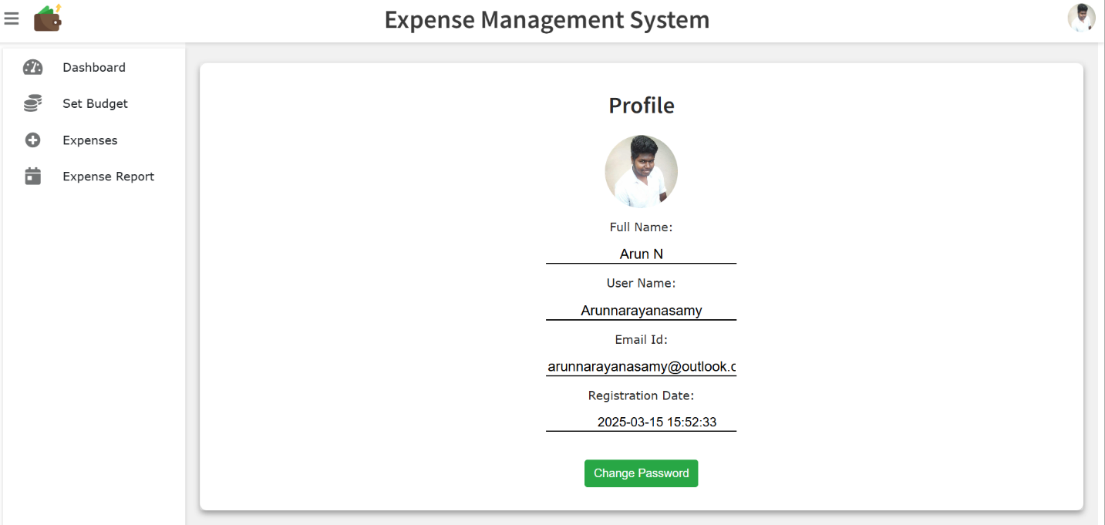

SET BUDGET

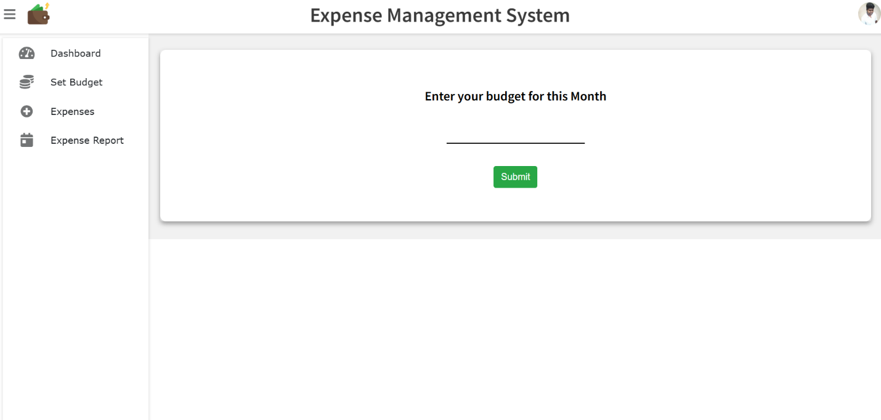

ADD EXPENSE

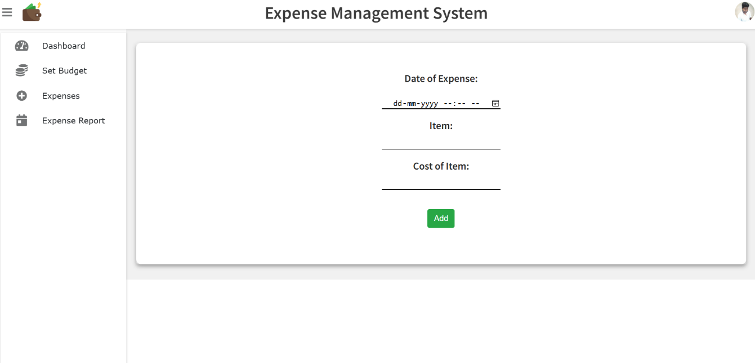

MANAGE EXPENSES

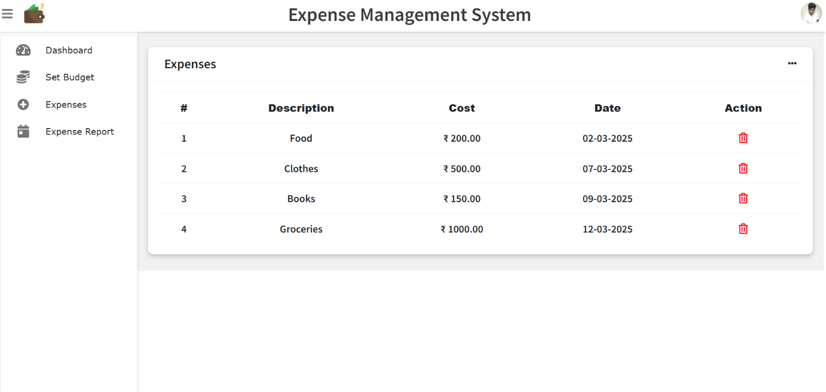

DATE-WISE EXPENSE REPORT

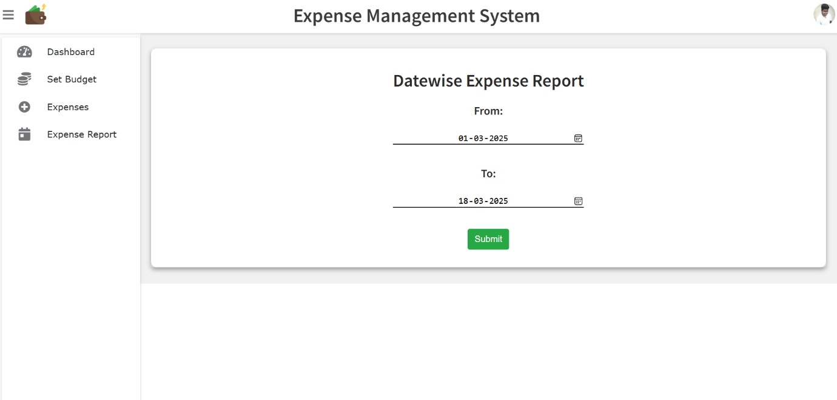

MONTH-WISE EXPENSE REPORT

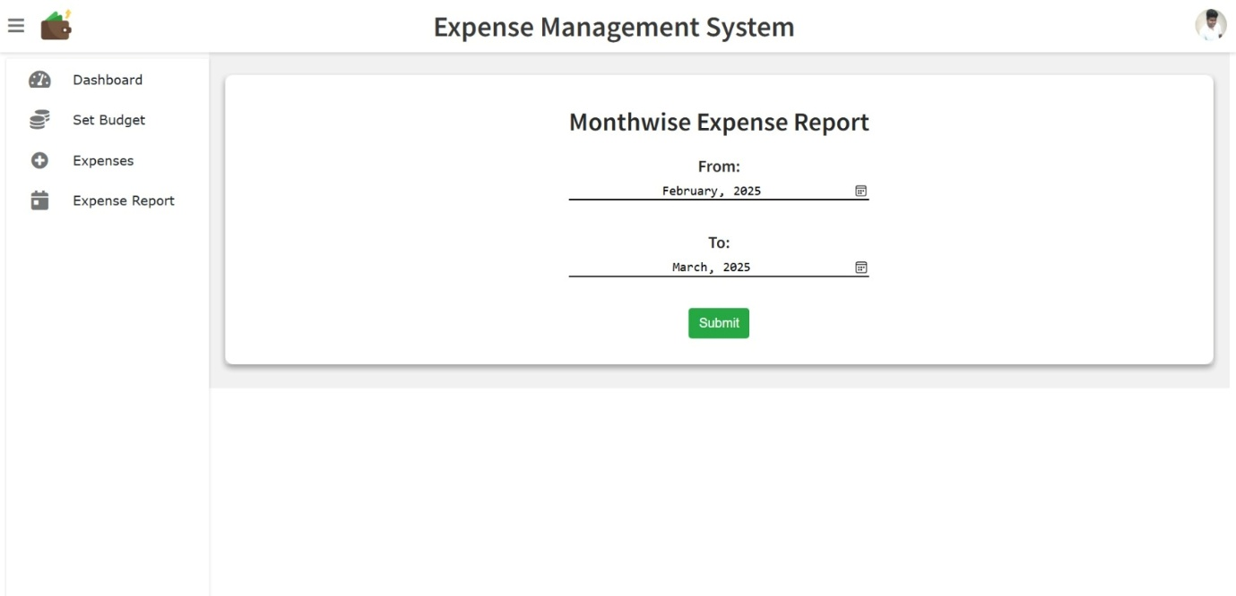

YEAR-WISE EXPENSE REPORT

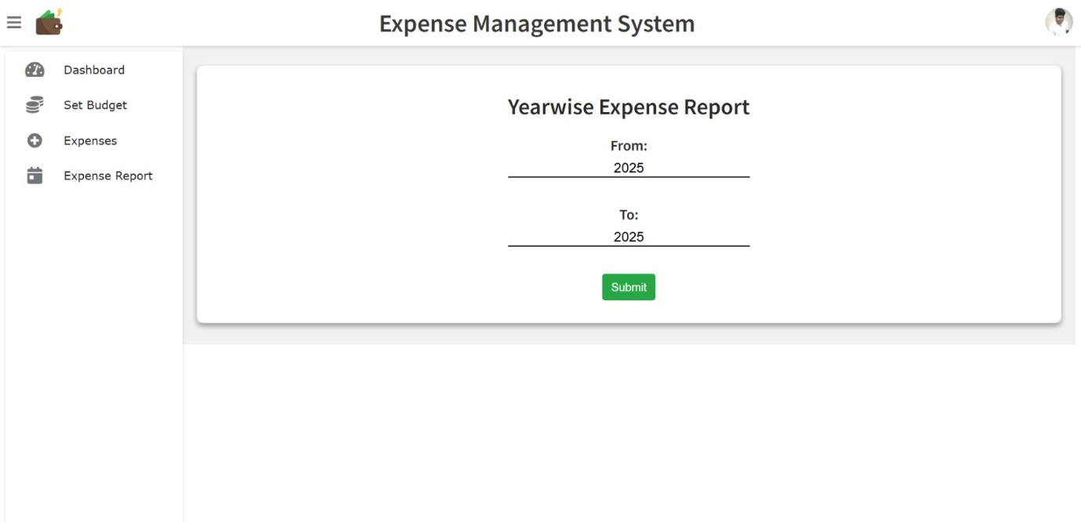

EXPENSE REPORT WITH GRAPH REPRESENTATION

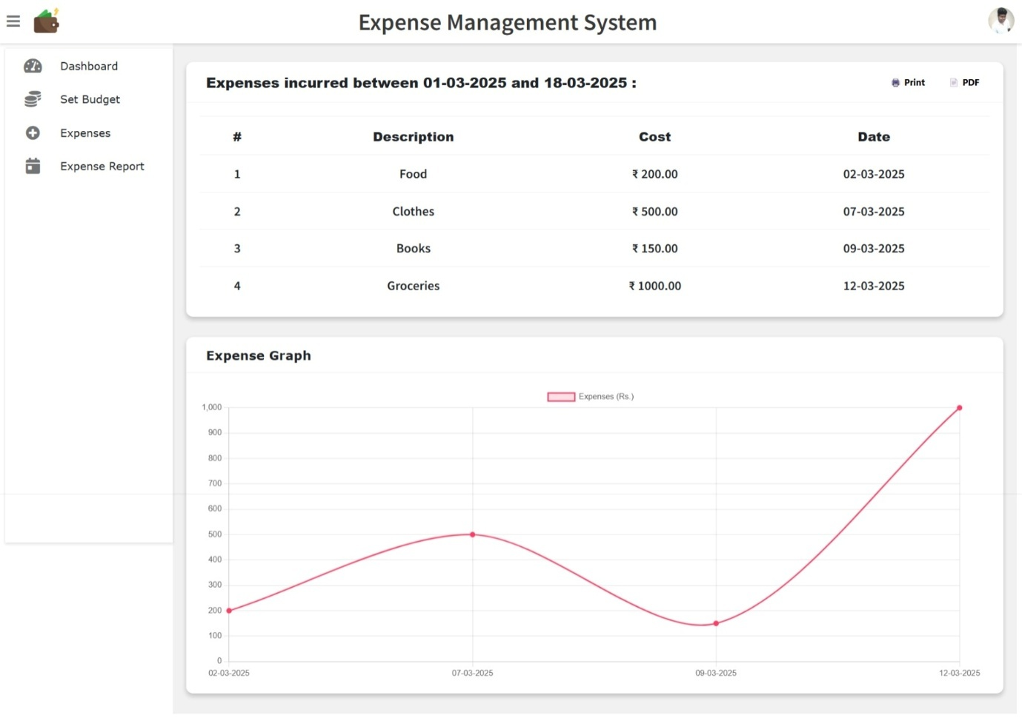

6.3 DATABASE TABLES

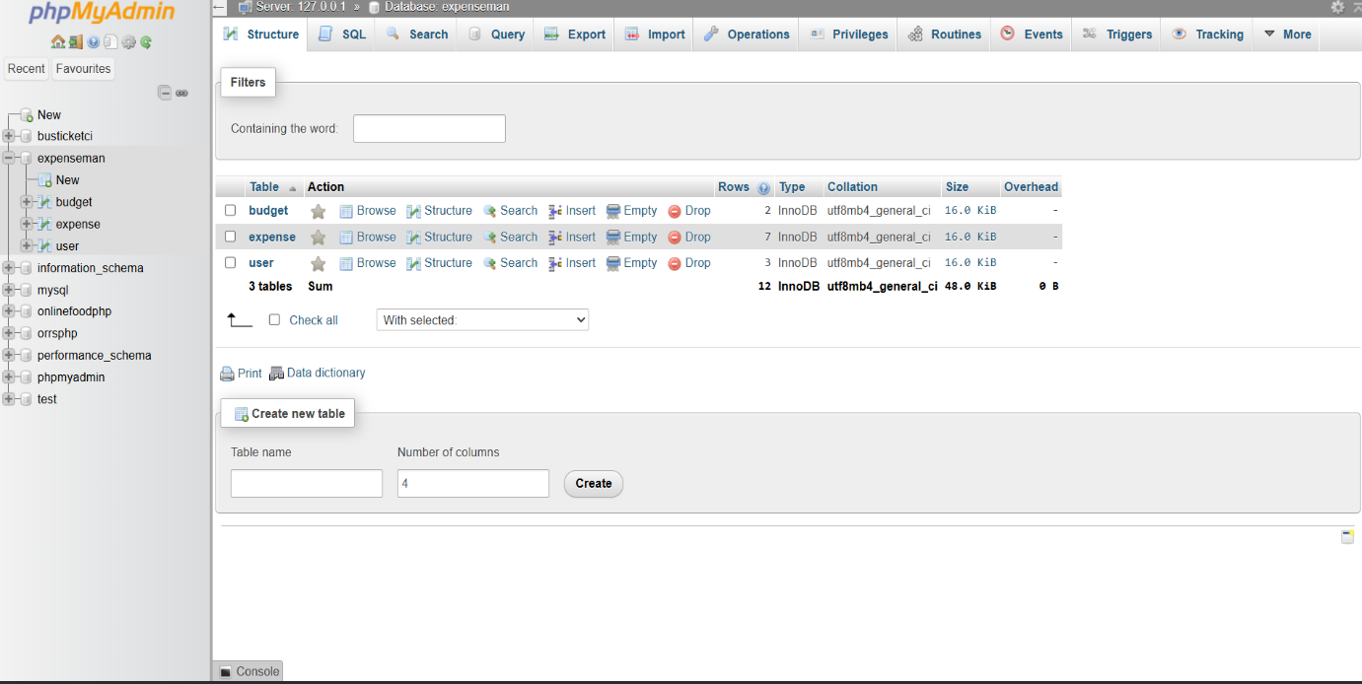

BUDGET

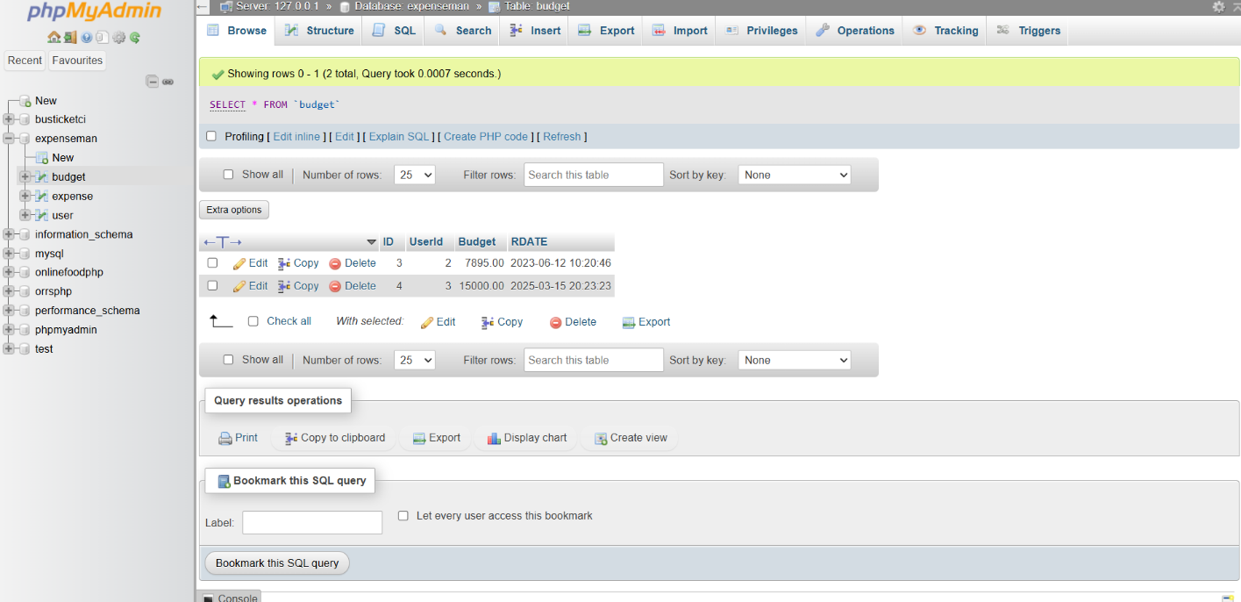

EXPENSE

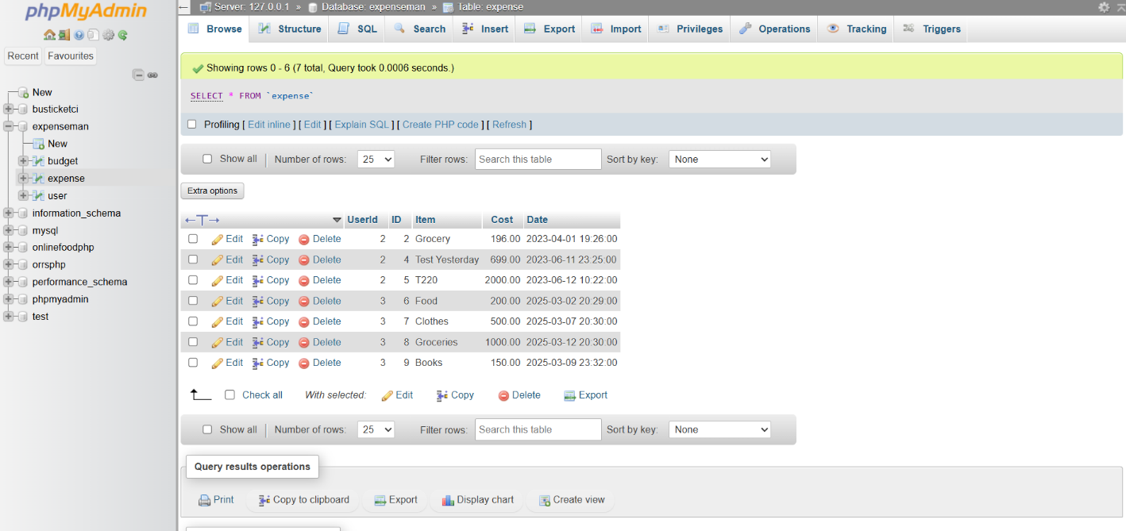

USER

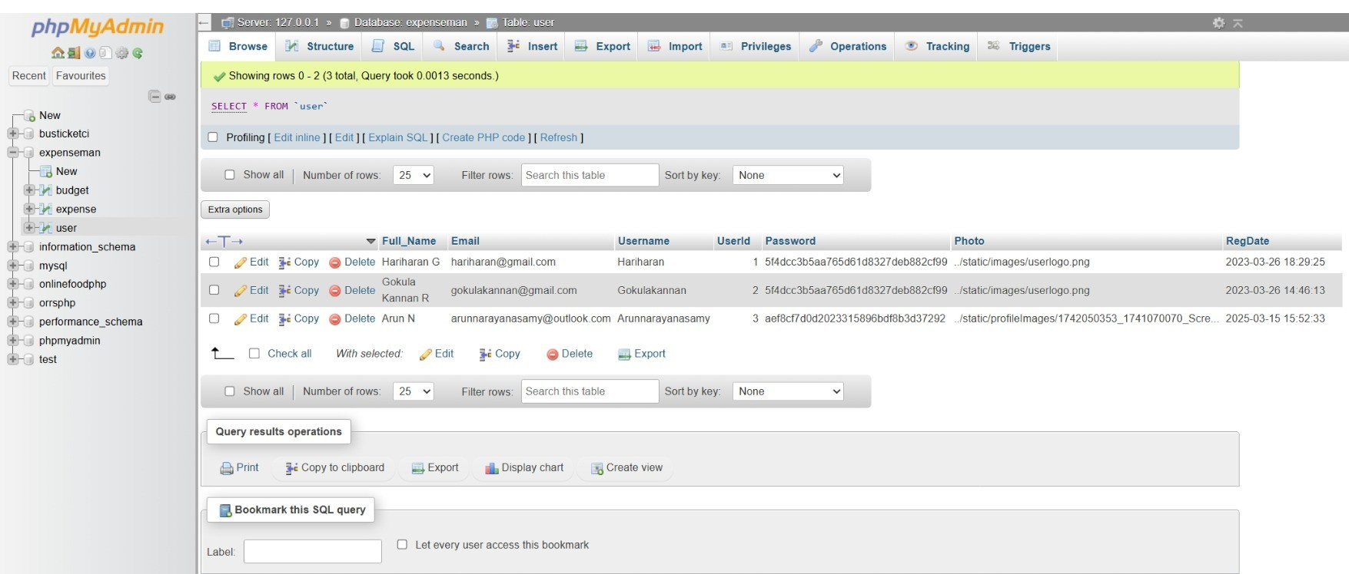

CHAPTER 7
CONCLUSION
The development of the expense management system represents a significant step toward simplifying personal financial management. This web-based application provides users with an easy and efficient way to track their daily expenses, manage financial records, and gain insights into their spending habits.
Enhancing Financial Awareness and Accessibility
At the core of the expense management system is the goal of empowering users to maintain financial discipline and transparency in their spending. By providing a structured way to log expenses and review financial data, the system enables individuals to stay organized and make informed financial decisions.
Improving Efficiency and Reliability
Traditional methods of tracking expenses, such as manual record-keeping or spreadsheets, are prone to errors, data loss, and inefficiency. This system overcomes these challenges by automating data storage, ensuring accuracy, and providing a secure environment for financial records.
Building a Sustainable Financial Management Tool
This project has not only provided a functional expense tracking solution but has also laid the foundation for future improvements. With potential enhancements such as better reporting tools, advanced analytics, and mobile compatibility, the system can continue to evolve, helping users gain better control over their finances.
Final Thoughts
The expense management system is more than just an application—it is a valuable financial companion that promotes better financial habits. By offering a simple, user-friendly, and reliable solution, this system makes expense tracking a hassle-free and effective process, helping users achieve greater financial stability and control over their expenditures.

CHAPTER 8
REFERENCES

8.1 Web Resources
  - Roger S. Pressman, Software Engineering: A Practitioner’s Approach, McGraw-Hill Education.
  - Ian Sommerville, Software Engineering, Pearson Education.
  - Jeffrey L. Whitten, Lonnie D. Bentley, Systems Analysis and Design Methods, McGraw-Hill.
  - Ramez Elmasri and Shamkant B. Navathe, Fundamentals of Database Systems, Pearson.
8.2 Web Resources
  - https://www.w3schools.com/
  - https://www.geeksforgeeks.org/
  - https://www.tutorialspoint.com/
  - https://developer.mozilla.org/en-US/ (MDN Web Docs)
  - https://www.php.net/ (Official PHP Documentation)
  - https://dev.mysql.com/doc/ (Official MySQL Documentation)
  - https://stackoverflow.com/ (For community Q&A and troubleshooting)
8.3 Project Development Tools
  - Visual Studio Code (https://code.visualstudio.com/)
  - XAMPP Server (https://www.apachefriends.org/index.html)
  - MySQL Workbench (https://www.mysql.com/products/workbench/)

